Software Requirements Specification
for
CAMPUSSHARE
Version 1.0 approved
Prepared by KANISHKA R
Coimbatore Institute of Technology
30/09/2026
Table of Contents
Table of Contents ii
Revision History ii
1. Introduction 1
1.1 Purpose 1
1.2 Document Conventions 1
1.3 Intended Audience and Reading Suggestions 1
1.4 Product Scope 1
1.5 References 1
2. Overall Description 2
2.1 Product Perspective 2
2.2 Product Functions 2
2.3 User Classes and Characteristics 2
2.4 Operating Environment 2
2.5 Design and Implementation Constraints 2
2.6 User Documentation 2
2.7 Assumptions and Dependencies 3
3. External Interface Requirements 3
3.1 User Interfaces 3
3.2 Hardware Interfaces 3
3.3 Software Interfaces 3
3.4 Communications Interfaces 3
4. Features 4
4.1 user registratoin and login 4
4.2 Item management
4.3 Borrow Request ,management
4.4 Return management
4.5 Notification system
4.6 admin management
5. Other Nonfunctional Requirements 4
5.1 Performance Requirements 4
5.2 Safety Requirements 5
5.3 Security Requirements 5
5.4 Software Quality Attributes 5
5.5 Business Rules 5
6. Database Design 5
6.1 Users Collection/Table
6.2 Items Collection/Table
6.3 Requests Collection/Table
6.4 Notifications Collection/Table
Appendix A: Glossary 5
Appendix B: Analysis Models 5
Appendix C: To Be Determined List 6

Revision History
Name | Date | Reason For Changes | Version

1. Introduction

1.1 Purpose
This document specifies the software requirements for Version 1.0 of the Campus Item Borrowing System (CIBS), a web-based application that enables students, faculty, and staff to request, borrow, and return shared items owned by a college or university — such as lab equipment, audio-visual gear, sports equipment, tools, and reference materials. This SRS covers the functional and non-functional requirements for the initial release and is intended to serve as the agreed basis for design, development, and acceptance testing of the system.

1.2 Document Conventions
Throughout this document, the word “shall” indicates a mandatory requirement, while “should” indicates a recommended but not mandatory capability. Each functional requirement is assigned a unique identifier in the form Campusshare so that it can be traced through design, implementation, and test artifacts. Requirement priority is expressed as High, Medium, or Low, where High denotes a requirement that must be present in the first release.

1.3 Intended Audience and Reading Suggestions
This SRS is intended for the following readers:
- Developers and software architects, who should focus on Sections 3, 4, and 5 for interface and feature-level detail.
- Project managers and product owners, who should review Sections 1 and 2 for scope and context before planning releases.
- Quality assurance engineers, who will use the numbered requirements in Section 4 as the basis for test case design.
- Campus administrators and item custodians (department staff who manage borrowable inventory), who are the primary stakeholders for the business rules in Section 5.
- End users (students, faculty, and staff), who may wish to review Section 2 for a plain-language overview of what the system will do.

1.4 Product Scope
Many departments currently track borrowable equipment using paper sign-out sheets or disconnected spreadsheets, which makes it difficult to know what is available, who currently holds an item, and when it is due back. CIBS replaces these manual processes with a single web application that maintains a searchable catalog of borrowable items, lets users submit borrow requests online, routes those requests to the responsible custodian for approval, and tracks due dates, returns, and item condition. The goal is to reduce item loss, shorten the time it takes to locate and borrow equipment, and give administrators visibility into utilization across departments. CIBS is limited to the borrowing and return workflow; it does not handle purchasing, procurement, or financial accounting for the items it tracks.

1.5 References
- IEEE Std 830-1998, IEEE Recommended Practice for Software Requirements Specifications.
- [Institution Name] Information Security and Acceptable Use Policy.
- [Institution Name] Web Accessibility Standard (WCAG 2.1 AA compliance).
- CIBS UI Style Guide and Wireframes (companion document, to be delivered with the design phase).

2. Overall Description

2.1 Product Perspective
CIBS is a new, standalone web application; it is not a modification of an existing system. It will authenticate users through the institution's existing Single Sign-On (SSO) identity provider rather than maintaining its own password store. CIBS replaces the paper- and spreadsheet-based tracking currently used by individual departments, and it is designed to be extensible so that a future phase could integrate with the library catalog system or a campus-wide asset management platform.

2.2 Product Functions
At a high level, CIBS will allow users to:
- Create and manage an account through campus SSO, with a profile reflecting their role (student, faculty, staff, or item custodian).
- Browse and search a catalog of borrowable items by category, department, availability, and keyword.
- Submit a borrow request for one or more items, specifying the desired pickup and return dates.
- Allow the responsible custodian to review, approve, or reject pending requests.
- Track active loans, due dates, and overdue items, and process returns including a condition check.
- Receive automated email/SMS reminders before an item is due and notices when it becomes overdue.
- Allow custodians and administrators to manage inventory records and generate utilization reports.

2.3 User Classes and Characteristics

USE CASE 1:STUDENT

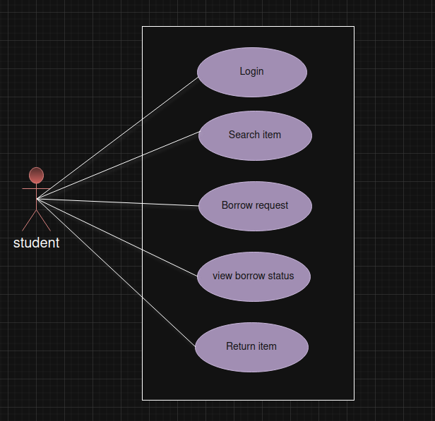

Precondition:Student is logged into the system.
Postcondition:Student successfully borrows an item, or receives appropriate feedback.
Trigger:Student selects "Borrow Item."
Main Success Scenario:

- Student logs in.
- Navigates to "Borrow Item" section.
- System displays available items for students.
- Student selects an item.
- System prompts for confirmation.
- Student confirms.
- System checks item availability and borrowing limits for student.
- System records the borrow transaction.
- Confirmation message displayed.

Exception Scenarios:

- Item unavailable (already borrowed).
- Student exceeded borrowing limit.
- Network/system error.

USE CASE 2: STAFF/FACULTY

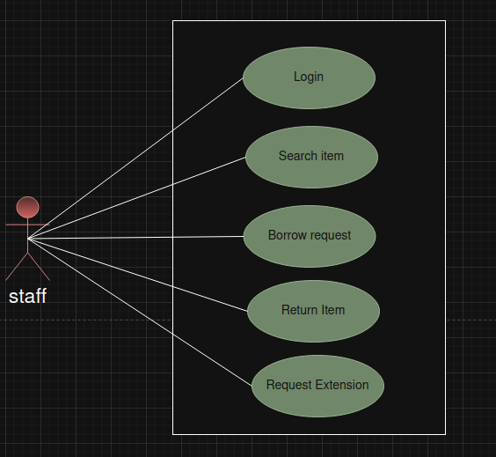

Precondition:Staff is logged into the system.
Postcondition:Staff successfully borrows an item, or receives appropriate feedback.
Trigger:Staff selects "Borrow Item."
Main Success Scenario:

- Staff logs in.
- Navigates to "Borrow Item."
- System shows available items for staff.
- Staff selects an item.
- System prompts for confirmation.
- Staff confirms.
- System validates item availability and staff borrowing limits.
- System records transaction.
- Confirmation message displayed.

Exception Scenarios:

- Item unavailable.
- Staff exceeds borrowing limit.
- System error or network failure.

USE CASE 3: ADMIN
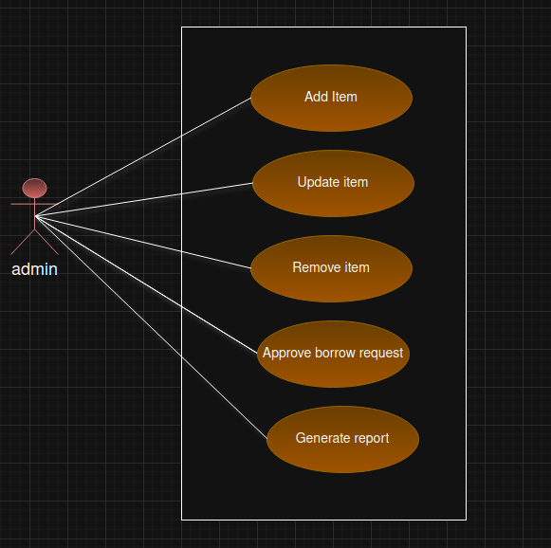

Precondition:Admin is logged into the system and has the necessary permission
Postcondition: Inventory is updated, or Borrowing/return transactions are recorded, or Admin receives
Trigger:Admin initiates a borrowing or inventory management action (e.g., "Borrow Item," "Return Item," "Add Item," "Update Item").

Main Success Scenario:

Borrowing an Item for Administrative Purpose

Admin logs into the system.

Navigates to "Manage Borrowings" or "Borrow Item" section.

System displays available items that can be borrowed for administrative purposes (if applicable).

Admin selects an item to borrow.

System prompts for confirmation and possibly additional details (e.g., reason, borrower info).

Admin confirms the operation.

System checks item availability and whether the admin has permission to borrow.

System updates records to reflect the borrowing transaction, including borrower info, date, and purpose.

Confirmation message is displayed to the admin.

Exceptions Scenario:

Unauthorized Operation:

Item Unavailable or Not Found:

System Error:

2.4 Operating Environment
CIBS is a responsive web application accessible from current versions of Chrome, Firefox, Safari, and Edge on desktop, tablet, and mobile devices. The application server and database will run on the institution's approved cloud or on-premises infrastructure and must operate behind the campus firewall and VPN policies where applicable.

2.5 Design and Implementation Constraints
- Authentication must integrate with the institution's SSO / identity provider (for example, SAML or OAuth2/OIDC); CIBS shall not store user passwords.
- The system shall comply with WCAG 2.1 Level AA accessibility guidelines.
- The system shall comply with the institution's data privacy and retention policies for personally identifiable information.
- The initial release shall support at least 5,000 registered users and 500 concurrent sessions without degraded performance.

2.6 User Documentation
CIBS will ship with an in-app help center covering account setup, browsing and requesting items, and returns; a short onboarding video for new users; and a separate administrator guide describing inventory management and reporting for custodians.

2.7 Assumptions and Dependencies
- Users have reliable access to the campus network or internet and an active institutional account.
- The campus SSO / identity provider is available and its API/protocol will not change materially during development.
- Departments will provide accurate initial inventory data for migration into the CIBS catalog.
- Email and/or SMS gateway services used for notifications are provisioned and approved by campus IT.

3. External Interface Requirements
3.1 User Interfaces
CIBS provides a responsive web interface with the following primary screens: a login screen(delegating to campus SSO), a catalog/search screen, an item detail and request screen, a “MyLoans” dashboard for end users, an approval queue and inventory console for custodians, anda reporting screen for administrators. All screens shall follow the CIBS UI Style Guide for layout,typography, and color, and shall meet WCAG 2.1 AA contrast and keyboard-navigationrequirements.

3.2 Hardware Interfaces
CIBS requires no dedicated hardware. It shall optionally support barcode or QR-code scanningusing a standard webcam or a connected USB barcode scanner to speed up check-out andcheck-in of physical items, but this capability is not required for core functionality.

3.3 Software Interfaces
• Identity Provider — CIBS authenticates users via the campus SSO service using SAML 2.0 or OAuth2/OIDC.
• Email/SMS Gateway — CIBS sends transactional notifications (confirmations,reminders, overdue notices) through the institution&#39;s approved SMTP relay and,optionally, an SMS gateway API.
• Database — CIBS persists catalog, user, and transaction data in a relational database(for example, PostgreSQL or MySQL).

3.4 Communications Interfaces
All client-server communication shall occur over HTTPS/TLS 1.2 or higher. CIBS exposes aREST API (JSON over HTTPS) for the web client and for any future integrations. Outboundemail notifications use SMTP over an encrypted connection.

4. System Features
This section organizes the functional requirements of CIBS by feature area. Each featureincludes a short description, its relative priority, representative user/system interactionsequences, and the itemized requirements that a development team can implement and a test team can verify.
4.1 User Registration and Authentication

4.1.1 Description and Priority
Allows a user to sign in to CIBS using their existing campus credentials and establishes theirrole (student, faculty, staff, or custodian) for the session.
Priority: High
4.1.2 Stimulus/Response Sequences
• User selects “Sign in” and is redirected to the campus SSO login page.
• User enters valid campus credentials; SSO redirects back to CIBS with an authenticatedsession.
• First-time users are prompted to confirm contact details used for notifications.
4.1.3 Functional Requirements
REQ-AUTH-01: The system shall redirect unauthenticated users to the institution login page.
REQ-AUTH-02: The system shall create a CIBS session only after receiving a valid assertion/token from the SSO provider.
REQ-AUTH-03: The system shall assign a user role (student, faculty, staff, custodian, or administrator) based on attributes supplied by the identity provider.
REQ-AUTH-04: The system shall allow a user to update their preferred notification email and phone number on first login.
REQ-AUTH-05: The system shall terminate a user & session after 30 minutes of inactivity.
4.2 Catalog Browsing and Search
4.2.1 Description and Priority
Lets any authenticated user browse the list of borrowable items and filter or search by category,department, and availability.
Priority: High
4.2.2 Stimulus/Response Sequences
• User navigates to the Catalog screen; the system displays available items in a paginatedgrid.
• User enters a keyword or selects a category filter; the system returns matching items within 2 seconds.
• User selects an item to view its detail page, including description, photo, and current availability.
4.2.3 Functional Requirements
REQ-CAT-01: The system shall display a paginated, sortable list of all active catalog items.
REQ-CAT-02: The system shall allow filtering of catalog items by category, department, and availability status.
REQ-CAT-03: The system shall support free-text keyword search across item name and description.
REQ-CAT-04: The system shall display, for each item, its current availability (available, on loan, under maintenance, or retired).
4.3 Item Borrowing Request
4.3.1 Description and Priority
Allows a user to request to borrow one or more available items for a specified date range.
Priority: High
4.3.2 Stimulus/Response Sequences
• User selects an available item and clicks “Request to Borrow.”
• User specifies the desired pickup date and return date and submits the request.
• The system validates the dates against the item&#39;s borrowing rules and creates a pending request.
4.3.3 Functional Requirements
REQ-BOR-01: The system shall allow a user to submit a borrow request for any itemmarked as available.
REQ-BOR-02: The system shall require a requested pickup date and return date, and shallreject a return date earlier than the pickup date.
REQ-BOR-03: The system shall enforce the maximum loan duration configured for the item&#39;s category (see Section 5.5, Business Rules).
REQ-BOR-04: The system shall prevent a user from submitting a new request for an item they already have on active loan or pending approval.
REQ-BOR-05: The system shall notify the responsible custodian by email when a new request is submitted.

4.4 Request Approval Workflow
4.4.1 Description and Priority
Allows the custodian responsible for an item to review pending requests and approve, reject, or place them on a waitlist.
Priority: High
4.4.2 Stimulus/Response Sequences
• Custodian opens the Approval Queue and reviews a pending request.
• Custodian approves the request; the system reserves the item and notifies the requesterwith pickup instructions.
• Custodian rejects the request with a reason; the system notifies the requester and releases the reservation hold.
4.4.3 Functional Requirements
REQ-APR-01: The system shall present custodians with a queue of pending requests for items in their department, sorted by submission date.
REQ-APR-02: The system shall allow a custodian to approve a request, which reserves the item for the requested date range.
REQ-APR-03: The system shall allow a custodian to reject a request and shall require a rejection reason of at least 10 characters.
REQ-APR-04: The system shall notify the requester by email within 5 minutes of an approval or rejection decision.
REQ-APR-05: The system shall automatically place a request on a waitlist if the requested item becomes unavailable before approval, and shall notify the requester of waitlist status.
4.5 Item Return and Condition Tracking
4.5.1 Description and Priority
Allows a custodian to record the return of a borrowed item, including its condition, and automatically closes the associated loan.
Priority: High

4.5.2 Stimulus/Response Sequences
• Borrower brings the item back to the custodian&#39;s location.
• Custodian locates the active loan in the system and marks the item as returned, noting its condition.
• The system updates the item&#39;s status to available (or under maintenance, if damage is reported) and closes the loan record.
4.5.3 Functional Requirements
REQ-RET-01: The system shall allow a custodian to record the return of a loaned item by scanning or searching for the associated loan.
REQ-RET-02: The system shall require the custodian to record the item&#39;s condition at return(good, damaged, or missing parts).
REQ-RET-03: The system shall set an item&#39;s status to “under maintenance” automatically when it is returned as damaged, removing it from the available catalog until a custodian clears it.
REQ-RET-04: The system shall record the actual return date/time and compare it against the due date to determine whether the loan was returned late.
4.6 Automated Notifications and Reminders
4.6.1 Description and Priority
Keeps borrowers and custodians informed of upcoming due dates, overdue items, and request status changes without manual follow-up.
Priority: Medium
4.6.2 Stimulus/Response Sequences
• The system identifies loans due within 24 hours and sends a reminder email to theborrower.
• The system identifies loans past their due date and sends an overdue notice to the borrower and a copy to the custodian.
4.6.3 Functional Requirements
REQ-NOT-01: The system shall send an email reminder to the borrower 24 hours before a loan&#39;s due date.
REQ-NOT-02: The system shall send an overdue notice to the borrower and the responsible custodian on the day a loan becomes overdue, and again every 3 days until the item is returned.
REQ-NOT-03: The system shall allow users to opt in to receive the same notifications via SMS in addition to email.

5. Other Nonfunctional Requirements
5.1 Performance Requirements
• The system shall return catalog search results within 2 seconds under normal load (up to 500 concurrent users).
• The system shall support at least 5,000 registered users and 500 concurrent active
sessions without degradation in response time.
• Page load time for the catalog and dashboard screens shall not exceed 3 seconds on a
standard broadband connection.
5.2 Safety Requirements
CIBS does not control physical equipment and therefore has no direct safety-of-life
requirements. However, the system shall maintain accurate, durable records of who currently holds each item, since this information may be relied upon during safety incidents, equipment
recalls, or loss investigations. The system shall perform automated daily backups of its database to prevent loss of borrowing records.
5.3 Security Requirements
• The system shall authenticate all users through the institution & SSO provider; CIBS shall not store user passwords.
• The system shall enforce role-based access control so that custodians can only manage
items belonging to their own department, and administrators have system-wide access.
• All data in transit shall be encrypted using TLS 1.2 or higher; sensitive data at rest shall be encrypted using industry-standard encryption.
• The system shall maintain an audit trail of approval, rejection, and inventory-change
actions for a minimum of 3 years.
5.4 Software Quality Attributes

• Availability — the system shall maintain at least 99.5% uptime during the academic term,excluding scheduled maintenance windows.
• Usability — a first-time user shall be able to locate an item and submit a borrow requestwithout external instructions, validated through usability testing.
• Maintainability — the system shall be built using modular, documented components toallow new item categories or approval rules to be added without code changes to the
core engine.
• Accessibility — all user-facing screens shall conform to WCAG 2.1 Level AA.
5.5 Business Rules
• Students may have a maximum of 3 active loans at a time; faculty and staff may have upto 10, unless a department custodian configures a different limit for a specific category.
• The default maximum loan duration is 14 days for equipment and 7 days for high-
demand items, configurable per category by a custodian.
• A user with two or more overdue items shall be blocked from submitting new borrowrequests until all overdue items are returned.
• Only a custodian assigned to a department may approve, reject, or modify requests foritems owned by that department; administrators may act on behalf of any department for support purposes.

6. Other Requirements
CIBS shall comply with applicable data protection regulations governing student records (for example, FERPA in U.S. institutions) when displaying or exporting borrowing history. The system database schema shall support future addition of a fines/fees module without requiring a
redesign of the core loan and catalog tables, although billing and payment processing are explicitly out of scope for Version 1.0.

Appendix B: Analysis Models
The design phase will produce supporting analysis models referenced by this SRS, including a borrowing-request state diagram (pending → approved/rejected → returned → closed) and an entity-relationship diagram covering Users, Items, Categories, and Loans. These diagrams will
be delivered as a companion design document and are intentionally not duplicated here to avoiddivergence between the two artifacts.

UML DIAGRAM:
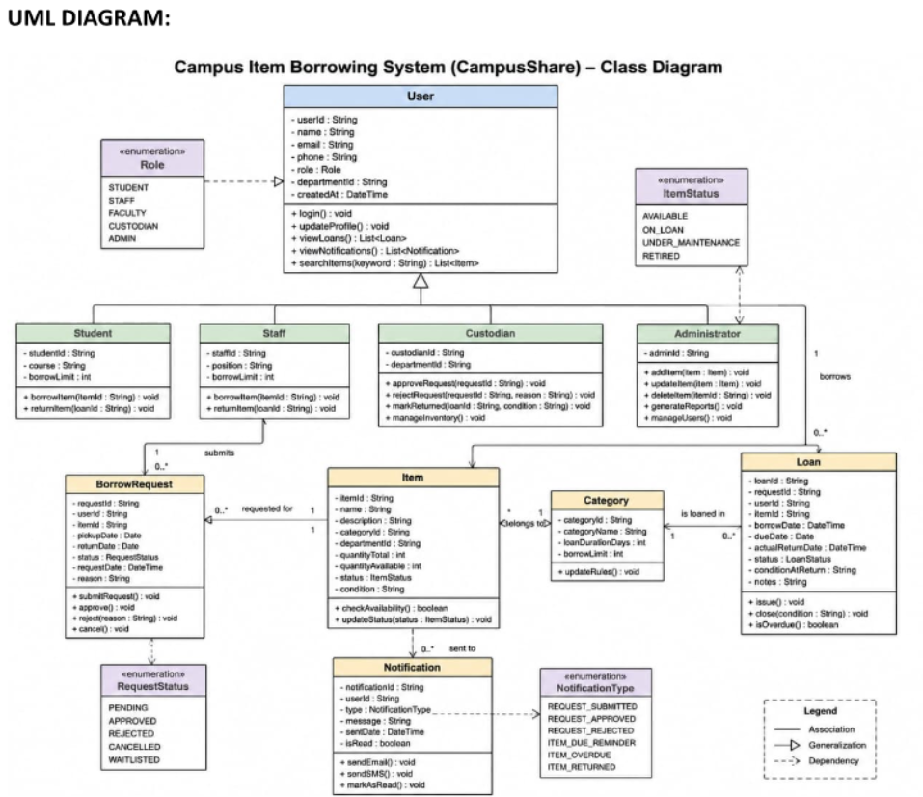

ACTIVITY DIAGRAM:
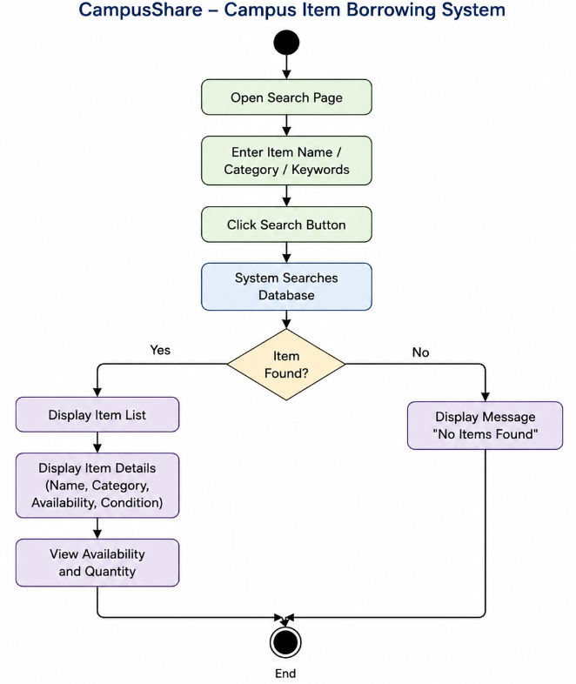

SEQUENCE DIAGRAM:
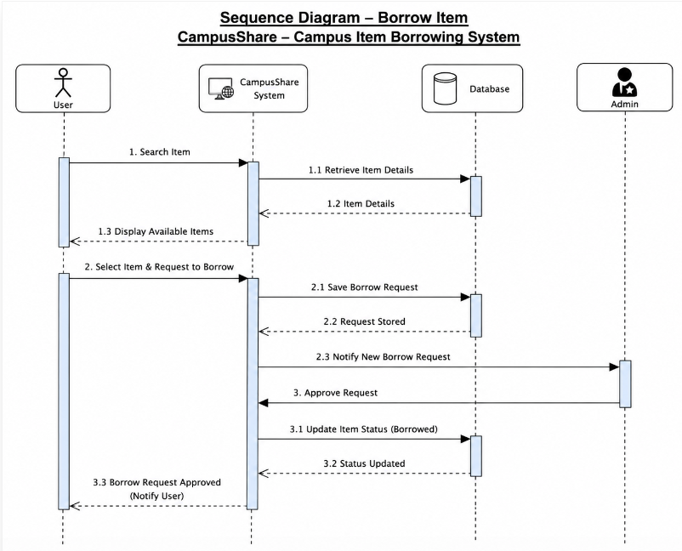

UML DEPLOYMENT DIAGRAM:
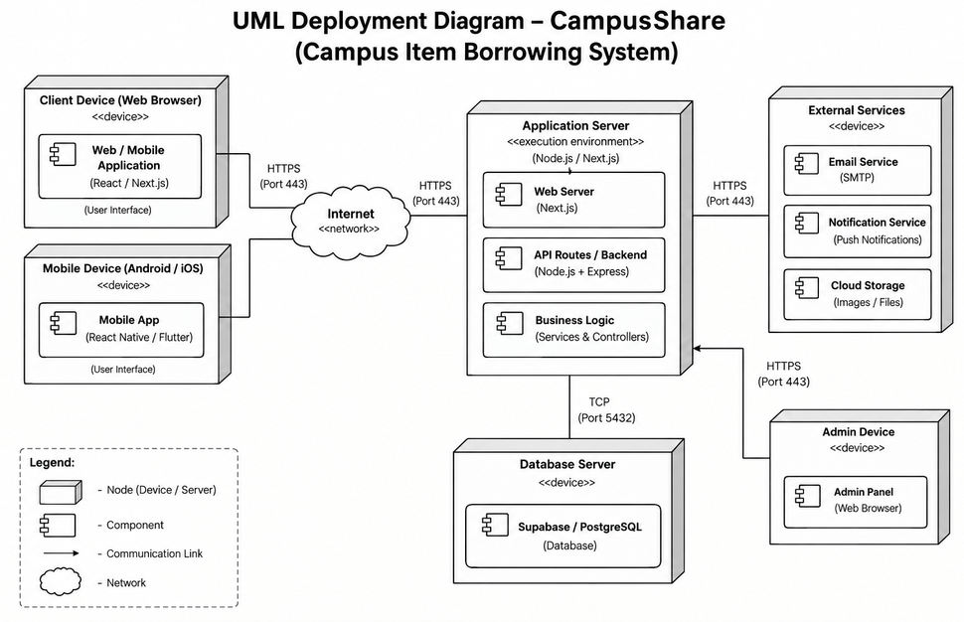

SOURCE CODE:
App/login/page.tsx:
'use client';
import React, { useState } from 'react';
import Link from 'next/link';
import { useRouter } from 'next/navigation';
import { Navbar } from '@/components/Navbar';
import { Toast } from '@/components/Toast';
import { ShieldCheck, ArrowRight, Sparkles, Lock, Mail } from 'lucide-react';
import { MockStore } from '@/lib/supabase/mockStore';

export default function AdminLoginPage() {
const router = useRouter();
const [email, setEmail] = useState('');
const [password, setPassword] = useState('');
const [loading, setLoading] = useState(false);
const [toast, setToast] = useState<{ message: string; type: 'success' | 'error' } | null>(null);

const handleLogin = async (e: React.FormEvent) => {
e.preventDefault();
if (!email) {
setToast({ message: 'Please enter administrator email address.', type: 'error' });
return;
}

setLoading(true);
try {
const user = MockStore.login(email, 'ADMIN');
setToast({ message: `Administrator authenticated successfully! Redirecting...`, type: 'success' });
setTimeout(() => {
router.push('/admin/dashboard');
}, 1000);
} catch (err: any) {
setToast({ message: err.message || 'Admin login failed.', type: 'error' });
} finally {
setLoading(false);
}
};

const handleQuickDemoAdminLogin = () => {
setEmail('admin@campus.edu');
setPassword('admin123');
const user = MockStore.login('admin@campus.edu', 'ADMIN');
setToast({ message: 'Logged in as Campus Administrator! Redirecting...', type: 'success' });
setTimeout(() => {
router.push('/admin/dashboard');
}, 1000);
};

return (
<div className="min-h-screen bg-zinc-50 dark:bg-zinc-950 text-zinc-900 dark:text-zinc-100 flex flex-col">
<Navbar />

{toast && <Toast message={toast.message} type={toast.type} onClose={() => setToast(null)} />}

<main className="flex-1 flex items-center justify-center p-4">
<div className="w-full max-w-md bg-white dark:bg-zinc-900 rounded-3xl border border-zinc-200 dark:border-zinc-800 shadow-2xl p-8 space-y-6">
<div className="text-center">
<div className="w-12 h-12 rounded-2xl bg-emerald-500/10 text-emerald-600 dark:text-emerald-400 flex items-center justify-center mx-auto mb-3">
<ShieldCheck className="w-6 h-6" />
</div>
<h2 className="text-2xl font-extrabold tracking-tight">Admin Console Login</h2>
<p className="text-xs text-zinc-500 dark:text-zinc-400 mt-1">
Authorized campus resource managers only
</p>
</div>

{/* Quick Demo Login Pill */}
<div className="p-3 rounded-2xl bg-emerald-50 dark:bg-emerald-950/40 border border-emerald-200/60 dark:border-emerald-800/60 flex items-center justify-between text-xs">
<div className="flex items-center gap-2 text-emerald-700 dark:text-emerald-300 font-medium">
<Sparkles className="w-4 h-4 text-emerald-500 shrink-0" />
<span>Demo Admin Account</span>
</div>
<button
onClick={handleQuickDemoAdminLogin}
type="button"
className="px-3 py-1 rounded-xl bg-emerald-600 text-white font-bold hover:bg-emerald-700 transition-colors text-[11px]"
>
One-Click Admin
</button>
</div>

<form onSubmit={handleLogin} className="space-y-4">
<div>
<label className="block text-xs font-semibold text-zinc-700 dark:text-zinc-300 mb-1.5">
Admin Email Address
</label>
<div className="relative">
<Mail className="w-4 h-4 text-zinc-400 absolute left-3.5 top-3.5" />
<input
type="email"
value={email}
onChange={(e) => setEmail(e.target.value)}
placeholder="e.g. admin@campus.edu"
className="w-full pl-10 pr-4 py-2.5 rounded-xl bg-zinc-50 dark:bg-zinc-800/50 border border-zinc-200 dark:border-zinc-700 text-sm focus:outline-none focus:ring-2 focus:ring-emerald-500"
required
/>
</div>
</div>

<div>
<label className="block text-xs font-semibold text-zinc-700 dark:text-zinc-300 mb-1.5">
Password
</label>
<div className="relative">
<Lock className="w-4 h-4 text-zinc-400 absolute left-3.5 top-3.5" />
<input
type="password"
value={password}
onChange={(e) => setPassword(e.target.value)}
placeholder="••••••••"
className="w-full pl-10 pr-4 py-2.5 rounded-xl bg-zinc-50 dark:bg-zinc-800/50 border border-zinc-200 dark:border-zinc-700 text-sm focus:outline-none focus:ring-2 focus:ring-emerald-500"
/>
</div>
</div>

<button
type="submit"
disabled={loading}
className="w-full py-3 rounded-xl bg-emerald-600 hover:bg-emerald-700 text-white font-bold text-sm shadow-lg shadow-emerald-600/25 transition-all flex items-center justify-center gap-2"
>
<span>{loading ? 'Authenticating...' : 'Sign In as Administrator'}</span>
<ArrowRight className="w-4 h-4" />
</button>
</form>

<div className="pt-4 border-t border-zinc-100 dark:border-zinc-800 text-center text-xs text-zinc-500">
Student portal?{' '}
<Link href="/login" className="font-bold text-indigo-600 dark:text-indigo-400 hover:underline">
Switch to Student Login
</Link>
</div>
</div>
</main>
</div>
);
}

App/dashboard/page.tsx:
'use client';

import React, { useState, useEffect } from 'react';
import Link from 'next/link';
import { Navbar } from '@/components/Navbar';
import { Sidebar } from '@/components/Sidebar';
import { StatCard } from '@/components/StatCard';
import { RequestTable } from '@/components/RequestTable';
import { Toast } from '@/components/Toast';
import { MockStore } from '@/lib/supabase/mockStore';
import { DashboardStats, BorrowRequest, UserProfile } from '@/lib/types';
import {
Box,
CheckCircle,
BookOpen,
Clock,
Users,
PlusCircle,
ShieldCheck,
ArrowRight
} from 'lucide-react';

export default function AdminDashboardPage() {
const [currentUser, setCurrentUser] = useState<UserProfile | null>(null);
const [stats, setStats] = useState<DashboardStats>({
totalItems: 0,
availableItems: 0,
borrowedItems: 0,
pendingRequests: 0,
totalStudents: 0
});
const [requests, setRequests] = useState<BorrowRequest[]>([]);
const [toast, setToast] = useState<{ message: string; type: 'success' | 'error' } | null>(null);

const loadData = () => {
const user = MockStore.getCurrentUser();
setCurrentUser(user);

const s = MockStore.getStats();
setStats(s);

const reqs = MockStore.getRequests();
setRequests(reqs);
};

useEffect(() => {
loadData();
}, []);

const handleApprove = (requestId: string, remark?: string) => {
try {
MockStore.approveRequest(requestId, remark);
setToast({ message: 'Borrow request APPROVED! Item available quantity updated.', type: 'success' });
loadData();
} catch (err: any) {
setToast({ message: err.message || 'Failed to approve request.', type: 'error' });
}
};

const handleReject = (requestId: string, remark?: string) => {
try {
MockStore.rejectRequest(requestId, remark);
setToast({ message: 'Borrow request REJECTED.', type: 'error' });
loadData();
} catch (err: any) {
setToast({ message: err.message || 'Failed to reject request.', type: 'error' });
}
};

const handleConfirmReturn = (requestId: string, remark?: string) => {
try {
MockStore.confirmReturn(requestId, remark);
setToast({ message: 'Item return CONFIRMED! Item restored to available stock.', type: 'success' });
loadData();
} catch (err: any) {
setToast({ message: err.message || 'Failed to confirm return.', type: 'error' });
}
};

const pendingRequestsList = requests.filter((r) => r.status === 'PENDING' || r.status === 'RETURN_PENDING');

return (
<div className="min-h-screen bg-zinc-50 dark:bg-zinc-950 text-zinc-900 dark:text-zinc-100 flex flex-col">
<Navbar userRole="ADMIN" userName={currentUser?.name} />

{toast && <Toast message={toast.message} type={toast.type} onClose={() => setToast(null)} />}

<div className="flex-1 flex max-w-7xl w-full mx-auto px-4 sm:px-6 lg:px-8 py-6 gap-6">
<Sidebar role="ADMIN" />

<main className="flex-1 space-y-8 min-w-0">
{/* Header Banner */}
<div className="p-6 sm:p-8 rounded-3xl bg-gradient-to-r from-zinc-900 via-zinc-800 to-emerald-950 text-white shadow-xl flex flex-col sm:flex-row items-start sm:items-center justify-between gap-4 border border-zinc-800">
<div>
<div className="inline-flex items-center gap-1.5 px-3 py-1 rounded-full text-[11px] font-bold uppercase tracking-wider bg-emerald-500/20 text-emerald-300 border border-emerald-500/30">
<ShieldCheck className="w-3.5 h-3.5" />
Administrator Control Center
</div>
<h1 className="text-2xl sm:text-3xl font-extrabold mt-2 tracking-tight">
Campus Resources & Borrowing Overview
</h1>
<p className="text-xs sm:text-sm text-zinc-400 mt-1">
Monitor live inventory stock, review pending borrow requests, and confirm returned items.
</p>
</div>

<Link
href="/admin/items/add"
className="px-4 py-2.5 rounded-xl bg-emerald-600 hover:bg-emerald-700 text-white font-bold text-xs shadow-lg shadow-emerald-600/20 transition-all shrink-0 flex items-center gap-1.5"
>
<PlusCircle className="w-4 h-4" />
<span>Add New Item</span>
</Link>
</div>

{/* Statistics Metrics Grid */}
<div className="grid grid-cols-1 sm:grid-cols-2 lg:grid-cols-5 gap-4">
<StatCard
title="Total Items"
value={stats.totalItems}
icon={Box}
colorScheme="indigo"
description="Across all categories"
/>
<StatCard
title="Available Items"
value={stats.availableItems}
icon={CheckCircle}
colorScheme="emerald"
description="Ready to borrow"
/>
<StatCard
title="Borrowed Items"
value={stats.borrowedItems}
icon={BookOpen}
colorScheme="blue"
description="Currently in use"
/>
<StatCard
title="Pending Requests"
value={stats.pendingRequests}
icon={Clock}
colorScheme="amber"
description="Needs review"
/>
<StatCard
title="Total Students"
value={stats.totalStudents}
icon={Users}
colorScheme="purple"
description="Registered users"
/>
</div>

{/* Pending Action Desk */}
<div className="space-y-4">
<div className="flex items-center justify-between">
<h2 className="text-lg font-bold text-zinc-900 dark:text-zinc-100 flex items-center gap-2">
<Clock className="w-5 h-5 text-amber-500" />
<span>Action Required: Pending Requests & Return Approvals</span>
</h2>
<Link href="/admin/requests" className="text-xs font-semibold text-indigo-600 dark:text-indigo-400 hover:underline flex items-center gap-1">
<span>View All Requests</span>
<ArrowRight className="w-3.5 h-3.5" />
</Link>
</div>

<RequestTable
requests={pendingRequestsList}
isAdmin={true}
onApprove={handleApprove}
onReject={handleReject}
onConfirmReturn={handleConfirmReturn}
emptyMessage="Great news! There are no pending borrow requests or return verifications requiring admin action right now."
/>
</div>
</main>
</div>
</div>
);
}
App/item/page.tsx:
'use client';
import React, { useState } from 'react';
import Link from 'next/link';
import { useRouter } from 'next/navigation';
import { Navbar } from '@/components/Navbar';
import { Sidebar } from '@/components/Sidebar';
import { Toast } from '@/components/Toast';
import { MockStore } from '@/lib/supabase/mockStore';
import { ItemCategory, ItemCondition } from '@/lib/types';
import { ArrowLeft, PlusCircle, Image as ImageIcon, MapPin, Box } from 'lucide-react';

const CATEGORIES: ItemCategory[] = [
'Books',
'Electronics',
'Sports Equipment',
'Laboratory Equipment',
'Stationery',
'Other'
];
export default function AdminAddItemPage() {
const router = useRouter();
const [itemName, setItemName] = useState('');
const [category, setCategory] = useState<ItemCategory>('Electronics');
const [description, setDescription] = useState('');
const [imageUrl, setImageUrl] = useState('');
const [quantity, setQuantity] = useState<number>(1);
const [location, setLocation] = useState('');
const [condition, setCondition] = useState<ItemCondition>('GOOD');
const [loading, setLoading] = useState(false);
const [toast, setToast] = useState<{ message: string; type: 'success' | 'error' } | null>(null);

const handleSubmit = (e: React.FormEvent) => {
e.preventDefault();
if (!itemName || !description || !location || quantity < 1) {
setToast({ message: 'Please fill in all required fields.', type: 'error' });
return;
}

setLoading(true);
try {
MockStore.addItem({
item_name: itemName,
category,
description,
image_url: imageUrl || 'https://images.unsplash.com/photo-1581092160607-ee22621dd758?w=600&auto=format&fit=crop&q=80',
quantity: Number(quantity),
location,
condition
});

setToast({ message: `${itemName} added to campus inventory successfully!`, type: 'success' });
setTimeout(() => {
router.push('/admin/items');
}, 1000);
} catch (err: any) {
setToast({ message: err.message || 'Failed to add item.', type: 'error' });
} finally {
setLoading(false);
}
};

return (
<div className="min-h-screen bg-zinc-50 dark:bg-zinc-950 text-zinc-900 dark:text-zinc-100 flex flex-col">
<Navbar userRole="ADMIN" />

{toast && <Toast message={toast.message} type={toast.type} onClose={() => setToast(null)} />}

<div className="flex-1 flex max-w-7xl w-full mx-auto px-4 sm:px-6 lg:px-8 py-6 gap-6">
<Sidebar role="ADMIN" />

<main className="flex-1 space-y-6 min-w-0">
<div>
<Link
href="/admin/items"
className="inline-flex items-center gap-1.5 text-xs font-semibold text-zinc-500 hover:text-zinc-900 dark:hover:text-zinc-100 mb-4 transition-colors"
>
<ArrowLeft className="w-4 h-4" />
<span>Back to Item Catalog</span>
</Link>

<h1 className="text-2xl font-extrabold text-zinc-900 dark:text-zinc-100 tracking-tight flex items-center gap-2">
<PlusCircle className="w-6 h-6 text-emerald-500" />
<span>Add New Campus Item</span>
</h1>
<p className="text-xs text-zinc-500 dark:text-zinc-400 mt-1">
Enter item specifications and storage location to add to the campus library
</p>
</div>

<form onSubmit={handleSubmit} className="bg-white dark:bg-zinc-900 rounded-3xl border border-zinc-200 dark:border-zinc-800 shadow-xl p-6 sm:p-8 space-y-6 max-w-2xl">
{/* Item Name */}
<div>
<label className="block text-xs font-semibold text-zinc-700 dark:text-zinc-300 mb-1.5">
Item Name *
</label>
<input
type="text"
value={itemName}
onChange={(e) => setItemName(e.target.value)}
placeholder="e.g. Scientific Calculator (Casio FX-991EX)"
className="w-full px-4 py-2.5 rounded-xl bg-zinc-50 dark:bg-zinc-800/50 border border-zinc-200 dark:border-zinc-700 text-sm focus:outline-none focus:ring-2 focus:ring-emerald-500"
required
/>
</div>

{/* Category & Condition */}
<div className="grid grid-cols-1 sm:grid-cols-2 gap-4">
<div>
<label className="block text-xs font-semibold text-zinc-700 dark:text-zinc-300 mb-1.5">
Category *
</label>
<select
value={category}
onChange={(e) => setCategory(e.target.value as ItemCategory)}
className="w-full px-4 py-2.5 rounded-xl bg-zinc-50 dark:bg-zinc-800/50 border border-zinc-200 dark:border-zinc-700 text-sm focus:outline-none focus:ring-2 focus:ring-emerald-500"
>
{CATEGORIES.map((cat) => (
<option key={cat} value={cat}>
{cat}
</option>
))}
</select>
</div>

<div>
<label className="block text-xs font-semibold text-zinc-700 dark:text-zinc-300 mb-1.5">
Condition *
</label>
<select
value={condition}
onChange={(e) => setCondition(e.target.value as ItemCondition)}
className="w-full px-4 py-2.5 rounded-xl bg-zinc-50 dark:bg-zinc-800/50 border border-zinc-200 dark:border-zinc-700 text-sm focus:outline-none focus:ring-2 focus:ring-emerald-500"
>
<option value="NEW">NEW</option>
<option value="GOOD">GOOD</option>
<option value="FAIR">FAIR</option>
</select>
</div>
</div>

{/* Description */}
<div>
<label className="block text-xs font-semibold text-zinc-700 dark:text-zinc-300 mb-1.5">
Item Description *
</label>
<textarea
value={description}
onChange={(e) => setDescription(e.target.value)}
placeholder="Provide details about specs, contents, edition, or usage guidelines..."
rows={3}
className="w-full px-4 py-2.5 rounded-xl bg-zinc-50 dark:bg-zinc-800/50 border border-zinc-200 dark:border-zinc-700 text-sm focus:outline-none focus:ring-2 focus:ring-emerald-500"
required
/>
</div>

{/* Storage Location & Quantity */}
<div className="grid grid-cols-1 sm:grid-cols-2 gap-4">
<div>
<label className="block text-xs font-semibold text-zinc-700 dark:text-zinc-300 mb-1.5">
Storage Location on Campus *
</label>
<div className="relative">
<MapPin className="w-4 h-4 text-zinc-400 absolute left-3.5 top-3.5" />
<input
type="text"
value={location}
onChange={(e) => setLocation(e.target.value)}
placeholder="e.g. Lab 201 - Shelf B"
className="w-full pl-10 pr-4 py-2.5 rounded-xl bg-zinc-50 dark:bg-zinc-800/50 border border-zinc-200 dark:border-zinc-700 text-sm focus:outline-none focus:ring-2 focus:ring-emerald-500"
required
/>
</div>
</div>

<div>
<label className="block text-xs font-semibold text-zinc-700 dark:text-zinc-300 mb-1.5">
Total Quantity *
</label>
<div className="relative">
<Box className="w-4 h-4 text-zinc-400 absolute left-3.5 top-3.5" />
<input
type="number"
min={1}
value={quantity}
onChange={(e) => setQuantity(Math.max(1, parseInt(e.target.value) || 1))}
className="w-full pl-10 pr-4 py-2.5 rounded-xl bg-zinc-50 dark:bg-zinc-800/50 border border-zinc-200 dark:border-zinc-700 text-sm focus:outline-none focus:ring-2 focus:ring-emerald-500"
required
/>
</div>
</div>
</div>

{/* Image URL */}
<div>
<label className="block text-xs font-semibold text-zinc-700 dark:text-zinc-300 mb-1.5">
Image URL (Optional)
</label>
<div className="relative">
<ImageIcon className="w-4 h-4 text-zinc-400 absolute left-3.5 top-3.5" />
<input
type="url"
value={imageUrl}
onChange={(e) => setImageUrl(e.target.value)}
placeholder="https://images.unsplash.com/..."
className="w-full pl-10 pr-4 py-2.5 rounded-xl bg-zinc-50 dark:bg-zinc-800/50 border border-zinc-200 dark:border-zinc-700 text-sm focus:outline-none focus:ring-2 focus:ring-emerald-500"
/>
</div>
<p className="text-[11px] text-zinc-400 mt-1">Leave empty to use high-quality default item photo.</p>
</div>

{/* Submit Button */}
<button
type="submit"
disabled={loading}
className="w-full py-3 rounded-xl bg-emerald-600 hover:bg-emerald-700 text-white font-bold text-sm shadow-lg shadow-emerald-600/25 transition-all flex items-center justify-center gap-2"
>
<PlusCircle className="w-4 h-4" />
<span>{loading ? 'Adding Item...' : 'Save & Publish Item'}</span>
</button>
</form>
</main>
</div>
</div>
);
}
APP/API/ITEM/ROUTE.TS:
import { NextResponse } from 'next/server';
import { MockStore } from '@/lib/supabase/mockStore';

export async function GET(request: Request) {
const { searchParams } = new URL(request.url);
const q = searchParams.get('q') || undefined;
const category = searchParams.get('category') || undefined;

const items = MockStore.searchItems(q, category);
return NextResponse.json({ items });
}

export async function POST(request: Request) {
try {
const body = await request.json();
const { item_name, category, description, image_url, quantity, location, condition } = body;

if (!item_name || !category || !description || !location || !quantity) {
return NextResponse.json({ error: 'All required item fields must be provided.' }, { status: 400 });
}

if (Number(quantity) < 1) {
return NextResponse.json({ error: 'Quantity must be at least 1.' }, { status: 400 });
}

const newItem = MockStore.addItem({
item_name,
category,
description,
image_url: image_url || 'https://images.unsplash.com/photo-1581092160607-ee22621dd758?w=600&auto=format&fit=crop&q=80',
quantity: Number(quantity),
location,
condition: condition || 'GOOD'
});

return NextResponse.json({ success: true, item: newItem });
} catch (error: any) {
return NextResponse.json({ error: error.message || 'Failed to add item.' }, { status: 400 });
}
}

APP/API/REQUEST/ROUTE.TS:
import { NextResponse } from 'next/server';
import { MockStore } from '@/lib/supabase/mockStore';

export async function GET(request: Request) {
const { searchParams } = new URL(request.url);
const studentId = searchParams.get('student_id');

if (studentId) {
const requests = MockStore.getStudentRequests(studentId);
return NextResponse.json({ requests });
}

const requests = MockStore.getRequests();
return NextResponse.json({ requests });
}

export async function POST(request: Request) {
try {
const body = await request.json();
const { student_id, item_id, expected_return_date } = body;

if (!student_id || !item_id) {
return NextResponse.json({ error: 'Student ID and Item ID are required.' }, { status: 400 });
}

const newRequest = MockStore.createBorrowRequest(student_id, item_id, expected_return_date);
return NextResponse.json({ success: true, request: newRequest });
} catch (error: any) {
return NextResponse.json({ error: error.message || 'Failed to submit borrow request.' }, { status: 400 });
}
}
DEMONSTRATION:


